Project Design Phase-II
Data Flow Diagram & User Stories
Date | 27 february 2026
Project Name | PlantCare AI – Plant Disease Detection System
Maximum Marks | 4 Marks

DFD LEVEL 0 (Context Diagram) :
- The user uploads a plant leaf image to the system.
- The system processes the uploaded image using a transfer learning-based CNN model to classify the plant disease.
- The predicted disease along with treatment recommendations is then displayed to the user.

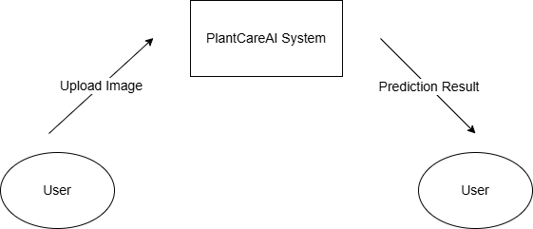

DFD LEVEL 1 (Detailed System Flow) :
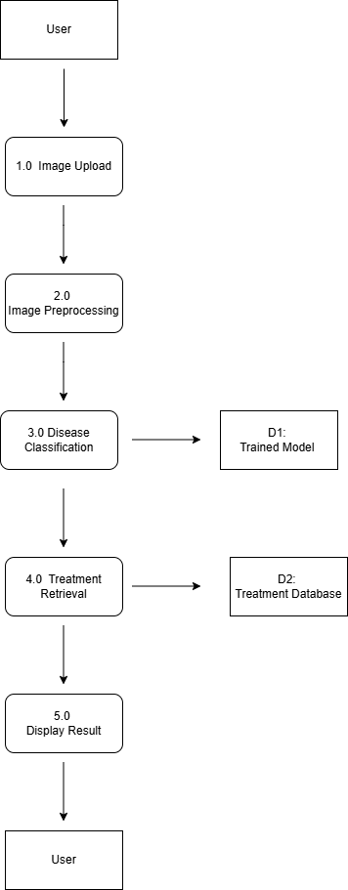
The DFD Level-1 diagram illustrates the internal working of the PlantCare AI system. The user uploads a plant leaf image, which is processed through the image preprocessing module. The processed image is then passed to the disease classification module, which uses a trained transfer learning-based CNN model stored in D1 to predict the disease. Based on the predicted disease, the system retrieves appropriate treatment information from D2 (Treatment Database). Finally, the disease details along with treatment suggestions are displayed to the user.

User Stories :

User Type | Functional  Requirement  (Epic) | User Story Number | User Story / Task | Acceptance criteria | Priority | Release
Customer  (Farmerer/ Gardener) | Image Upload | USN-1 | As a user, I want to upload a plant leaf image so that the system can detect the disease. | The system should allow JPG/PNG image upload successfully. | High | Sprint-1
 | Image Validation | USN-2 | As a user, I want the system to validate the uploaded image format so that incorrect files are rejected. | The system displays an error message for invalid file formats. | High | Sprint-1
 | Disease Classification | USN-3 | As a user, I want the system to analyze the image using a transfer learning model so that the disease can be predicted accurately. | The system predicts the plant disease with a result displayed on the screen. | High | Sprint-1
 | Treatment Suggestion | USN-4 | As a user, I want to receive treatment suggestions after disease detection so that I can take corrective action. | The system displays disease name along with treatment recommendations. | High | Sprint-1
 | Result Display | USN-5 | As a user, I want the result to be displayed clearly so that I can understand the disease information easily. | Disease name and treatment information are shown clearly on the result page. | Medium | Sprint-1

